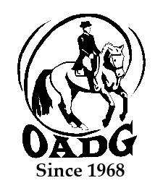

# 2025 OADG Team Challenge Team Name Declaration Form and Scores (at year end)

# Team results must be submitted by deadline on OADG website

***You may email this form to save paper & time***

This form **is required** if you are applying for the Team Challenge Award and for submitting scores.

OADG will allow a team to be declared with four (4) horse and rider combinations - but only the top scores from three (3) rider/horse combinations can be submitted for awards.

Please see full criteria details on the OADG website [www.ottawadressage.ca](http://www.ottawadressage.ca)

**The deadline for declaring your team is April 1st**. Entries will be accepted after this date but must be received prior to all members competing.

Name of Team: ________________________________________________________________________

Show Circuit: (circle one) ESD/Schooling Silver Gold

Names of Team Members

|  |  |  |  |  |  |  |  |
| --- | --- | --- | --- | --- | --- | --- | --- |
| **Rider** | **Horse** | **Indicate**  **JR, AA or O** | **Show, date and class** | **Score 1** | **Score 2** | **Score 3** | **Total** |
|  |  |  |  |  |  |  |  |
|  |  |  |  |  |  |  |  |
|  |  |  |  |  |  |  |  |
|  |  |  |  |  |  |  |  |

Contact Signature: ____________________________________________________________

Contact E-mail: _______________________________________________________________

Contact Phone Number: ________________________________________________________

**Email to:** [awards@ottawadressage.ca](mailto:awards@ottawadressage.ca)

*(signature not required)*

*This form must be* ***received*** *by the deadline.*